HANDLING MISSING DATA IN ETL
QUESTIONS :
Q1. What are the most common reasons for missing data in ETL pipelines?
Ans 1: 1. User error : When user forgot to enter the details .
2. System or software Failure : By mistake system deletes the data .
3. Optional Field : sometimes data column or filed is not filled due to optional.
4.Human Error : Accidently deleted by humans
5.Data Integration field issue : when system gets confused and replaces data with blanks while comparing the data and gets confused due to format error.
Q2. Why is blindly deleting rows with missing values considered a bad practice in ETL?
Ans 2: Blindly deleting rows with missing values considered a bad practice in ETL because it may cause deletion of the data which is useful for us and can create a problem to find the insights or whatever we want to find from the data.
For example, if 50 customers have missing income but their other information is complete, deleting all 50 rows means losing all their customer information.
Therefore, the reason and percentage of missing data should be checked before deleting records.

Q3. Explain the difference between: Listwise deletion Column deletion Also mention one scenario where each is appropriate.
Ans 3: Listwise Deletion:
The entire row is removed if it contains a missing value.
Example: If Region is missing, the complete customer record is deleted.
Appropriate when: Only a small number of records have missing values and removing them will not significantly affect the analysis.
Column Deletion:
The entire column is removed when it contains a large amount of missing data and is not important for the analysis.
Appropriate when: A column has too many missing values and is not required for the analysis.

Q4. Why is median imputation preferred over mean imputation for skewed data such as income?
Ans 4: Income data can be skewed because of very high-income values.
The mean is strongly affected by extreme values, whereas the median is less affected by them.
Therefore, median imputation is generally preferred for skewed data such as income.

Q5. What is forward fill and in what type of dataset is it most useful?
Ans 5: Forward Fill replaces a missing value with the previous available value.
Example : 65000 ,NaN,NaN,58000
After Forward fill
65000 , 65000 , 65000 , 58000
It is especially useful for time-series or sequential datasets.
Q6. Why should flagging missing values be done before imputation in an ETL workflow?
Ans 6 : Flagging missing values before imputation helps us identify which values were originally missing.
For example:
Income = NaN
Income_Missing_Flag = 1
After imputation, the income may have a value, but the flag still shows that the original value was missing.

Q7. Consider a scenario where income is missing for many customers.
How can this missingness itself provide business insights
Ans 7:If many customers have missing income, it may indicate:
- Customers are unwilling to provide income information.
- There may be problems in the data collection process.
- Missing income may be associated with certain customer groups.
- The business may need to improve its income-data collection process.
SECTION B – PRACTICAL QUESTIONS
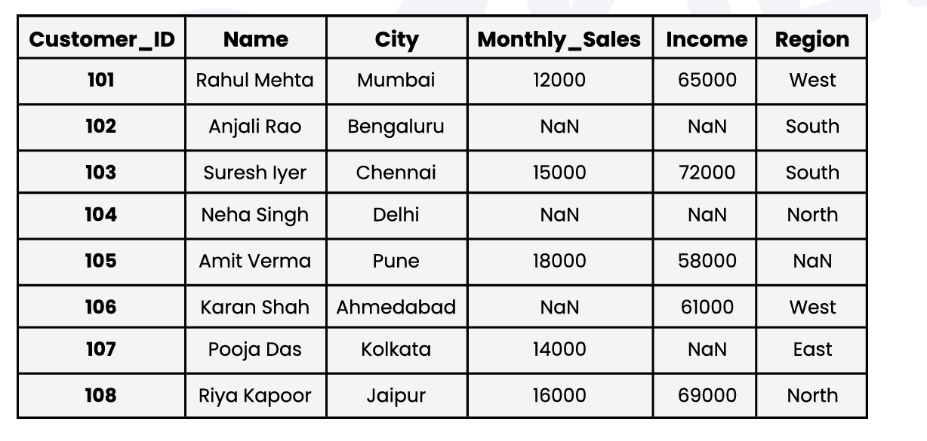
Use the given dataset for all questions.
Q8. Listwise Deletion Remove all rows where Region is missing.
Tasks: Identify affected rows : 105 Amit Yadav Pune 18000 58000 NaN
Show the dataset after deletion :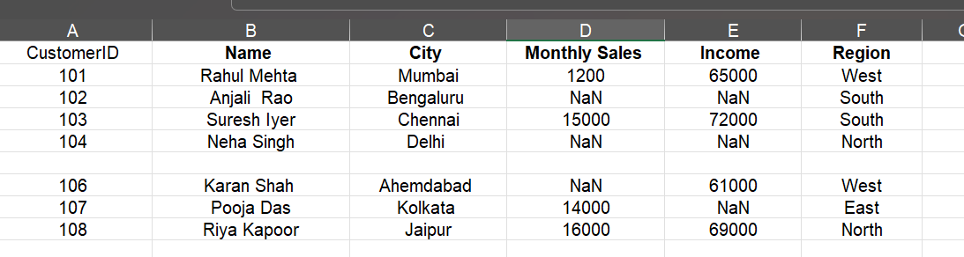
Mention how many records were lost : only 1 record is lost

Q9. Imputation Handle missing values in Monthly_Sales using: Forward Fill Tasks:
Apply forward fill Show before vs after values
Explain why forward fill is suitable here
Before: 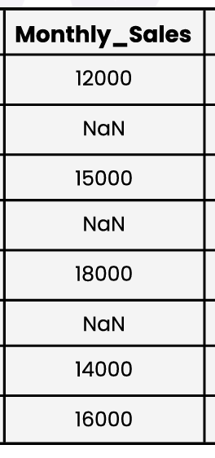
After : 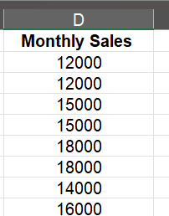
Forward fill is suitable here because it fills missing Monthly_Sales values with the previous available value. This is useful when the previous value is relevant to the missing value, especially in sequential or time-based data.

Q10. Flagging Missing Data Create a flag column for missing Income.
Tasks: Create Income_Missing_Flag (0 = present, 1 = missing) :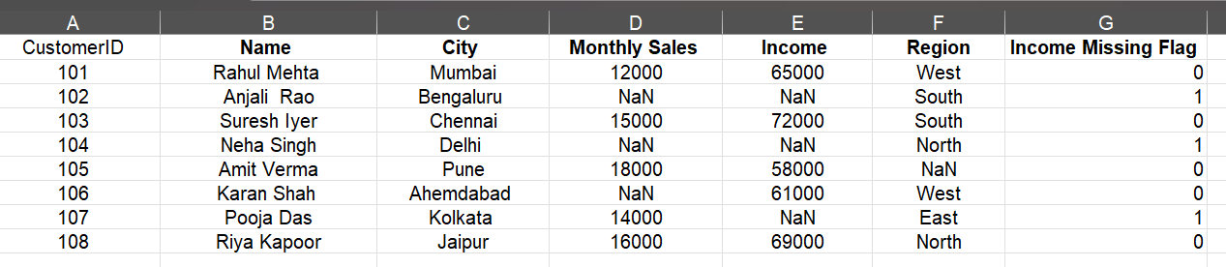
Show updated dataset
Count how many customers have missing income : 3

